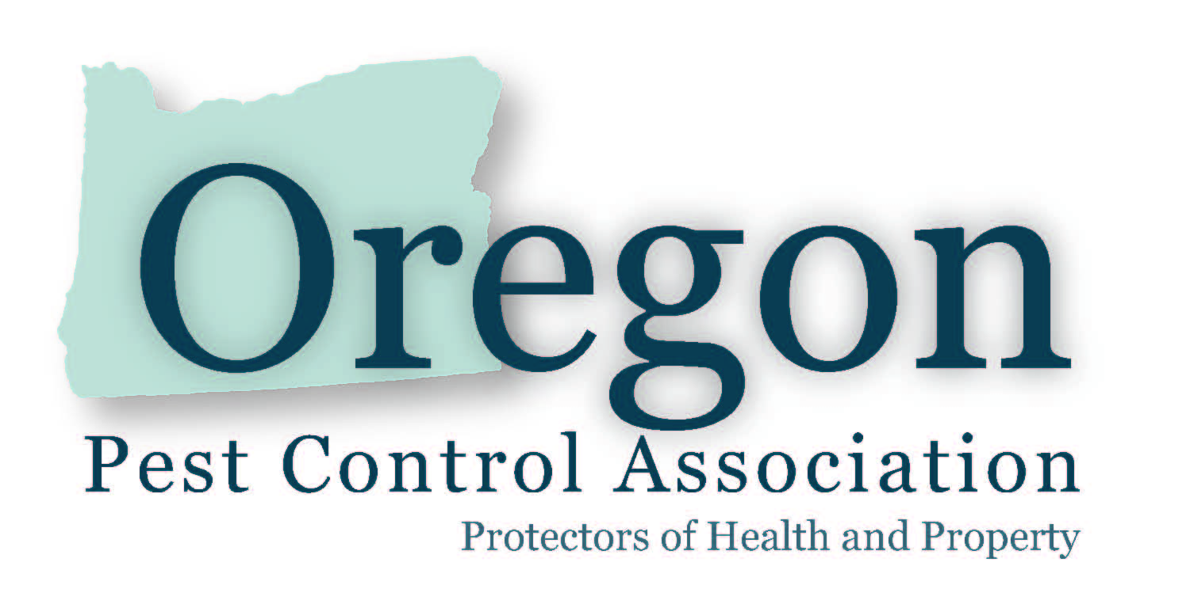
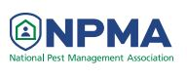
MEMBERSHIP APPLICATION

NPMA and OPCA Joint Membership
For July 1, 2017 – June 30, 2018

COMPANY INFORMATION
Legal Name of Firm: ______________________________________________________________________
dba used in Oregon (if applicable):___________________________________________________________
Operator's License #: _____________ CCB Registration #: _________________________
Applicator's License #: __________ OCHI #: _______________________(if applicable)
Years in business: __________ # Employees: __________
Phone: _________________________ Fax: _______________________Cell: ________________________
E-mail: _________________________________________ Website:_________________________________
Mailing Address: __________________________________________________________________________
City:____________________________________________________St:_______Zip:____________________
Designated Company Representative:__________________________________ Title: __________________
Alternate Company Representative:_____________________________________ Title: _________________
MEMBERSHIP HISTORY

□ Our company has been an OPCA or NPMA member in the past. Year(s) __________
□ Our company has never been a member of OPCA or NPMA.

TYPES OF SERVICES PROVIDED

□ General Pest Control □ Fumigation □ Termite Control □ Inspection for Real Estate
□ Structural Repairs □ Sale of Products □ Ornamental Pest Control □ Other ________________
□ Weed Control □ Pest Bird Control □ Wildlife Control

WEBSITE INFORMATION

The OPCA Website lists all member companies on its website. Consumers can locate companies that service their area(s). All member companies appear with company name, phone number, and website address. Also, please list the counties in which you provide services: County 1 _____________Phone _________ County 2 _____________Phone _____________

AGREEMENTS

This is to certify that I have read and understand the Code of Ethics and the Bylaws of the Oregon Pest Control Association and agree to abide by same. By joining as an Active member I understand that I will also be joining the National Pest Management Association. I understand that I will also be joining Oregonians for Food and Shelter. As an Active member I further understand that the Oregon Pest Control Association Uniform Structural Wood Destroying Organism Inspection Report and various other forms of the corporation are protected by copyright laws of the United States of America and may not be copied, reproduced, altered or modified, in whole or in part without the express written permission of the Oregon Pest Control Association. Members in good standing of the Oregon Pest Control Association are entitled to use copyrighted forms of the corporation.

SIGNATURE
____________________________________________ ________________
Signature of Designated Representative or Manager/Principal Date

MEMBERSHIP APPLICATION
(page2)

OPCA PROCEDURES FOR NEW APPLICATIONS

New member applications are handled ion the following manner, pursuant to our bylaws. Member candidates are reviewed with the Oregon Department of Justice, CCB and Oregon Department of Agriculture making sure License and insurance are current and for any License violation or civil penalties issued. The member application is posted to the membership for (15) days after receiving application for comment. Prior membership (re-instatement of membership) is up to one year. The OPCA board of directors has an additional (15) days past the membership opportunity to comment period to gather and verify all information on application(s) and vote.

□ Active Member Dues - select level, see benefits* below

Company Annual Sales Volume OPCA Dues + NPMA Dues = Total Dues
□ $0 - $200,000 $175 $110 = $285
□ $200,001 - $500,000 $175 $180 = $355
□ $500,001 - $1,000,000 $175 $470 = $645
□ $1,000,001 - $2,500,000 $175 $715 = $890
□ Over $2,500,001 $175 Call for dues schedule

TOTAL ACTIVE DUES ENCLOSED: $ _________________

□ Active Member, NPMA dues are paid through corporate office.

For Active members whose NPMA dues are paid by the corporate office. Dues: $175
Corporate Member’s NPMA member ID: __________________ (required)
Corporate office contact person:________________________

□ Associate Member Dues

For related industries (home inspectors, etc) who are not licensed pest control companies. Dues: $175

MAILING INFO

Mail this application, along with your check to: Oregon Pest Control Association
PO Box 2244
Salem, OR 97308-2244
□ Call me, I’d like to pay by Credit card

QUESTIONS? Phone: 503-363-4345 Fax: 503-585-8547

Active Member benefits include:

- Voting privileges
- Discounted rate at conferences, educational seminars and social events of the Association
- Joint Membership with the National Pest Management Association
- Serve on committees and hold office or serve on the nominating committee or chair committees
- Use of OPCA’s Logo and copyrighted materials of the corporation.

